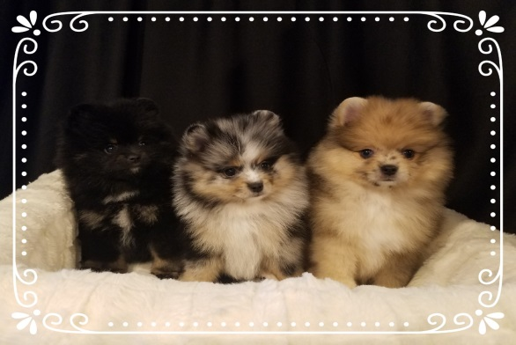

Bill of Sale & Puppy Contract

The following dog, on this day ______________has been sold to the persons listed below. Dog is purchased from “Breeder”, ___________________(Fantazia Pomeranian’s).

Buyer’s Name:________________________ ___________________________________
Home Address:_________________________ ________________
City: _________ ____ _________State:__________Zip Code:_______________
Phone: _______________________________
Email Address:_____________________________ ______________________________
Price of Dog:____________________ Shipping Cost: _____________________
Deposit received: _________________ On: ____________________

Date of Birth:______________________
Litter or Registration #: _________________
Sex: ___________
Color: _____________________________
Sire:__________________________________ AKC# ____________________
Dam: ____________________________ AKC# ____________________

To the best of the seller’s knowledge, this puppy is in good health at the time of sale. The buyer will have 48 hours to have the puppy examined by their own veterinarian, at their own expense. If the puppy is found to be diseased by a licensed veterinarian, the buyer may return the puppy to the breeder at the buyer’s expense. Notice of intent to return the puppy must be given to the breeder within 48 hours of the date of sale along with a statement in writing from the buyer’s veterinarian as to the health problem. A replacement puppy will be made when one becomes available. Replacement is the only option. This puppy is sold with no warranties, either expressed or implied in “as is” condition with no guarantees other than those stated herein. There will be no guarantee of color or size. Returning the puppy will be at the buyer’s expense. There is no guarantee against accidents. No veterinary bills will be paid by the breeder.
The puppy is up-to-date on vaccines and the buyer will receive a health record upon sale. The buyer agrees to finish all puppy vaccines before taking their puppy out in public, letting the puppy on public sidewalks and grasses, or letting the puppy be touched by people outside of their family. This will reduce any chances of your puppy picking up communicable diseases. There is no guarantee against sickness not contracted on the breeder’s premises.
This puppy is being sold as Pet only and is to be registered with limited AKC registration, spaying/neutering is required by 1 year of age at buyer’s expense.
The buyer agrees to return the puppy to the breeder if for any reason the buyer no longer wants to or is unable to keep the puppy. Breeder agrees to either assist buyer in finding another suitable home where the puppy will receive proper care or to accept the puppy back at any time with no refund to be given to the buyer as breeder would accept responsibility for the puppy and will be responsible for the future cost of care.
The buyer agrees at no time will the buyer sell or give the puppy to a pet store, a puppy mill, dog pound, or a dog broker or any similar enterprise or sell at an auction.
This contract represents the entire agreement between the parties. No other agreements or promises, verbal or implied included unless specifically stated herein. When the seller and buyer execute this contract, it will be binding upon both parties, subject and pursuant to the terms and conditions herein.
If for any reason, legal action were to be taken against Fantazia Poms, it must be taken up in my state (Michigan) at my district court house in Wayne County.
Having read the above, and with full understanding of the contents herein, I willingly enter into this agreement:

Buyer’s Signature _________________________________________Date:________________
Buyer’s Signature ___________________ Date:_________________
Seller’s Signature ___________________ Date:_________________

